Garden of War Guide (IN PROGRESS)

@fulldecent draft 3 2020-08-20:

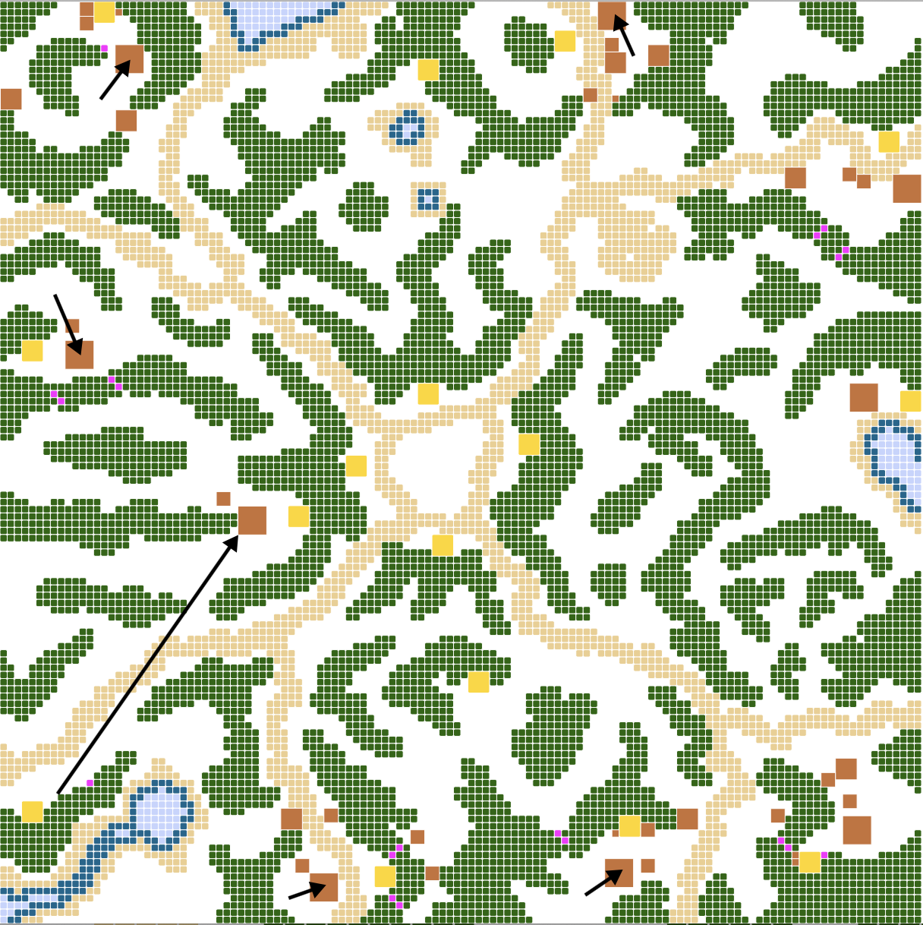

@fois[as] / Clan Absolute Synergy 2019-10-03:

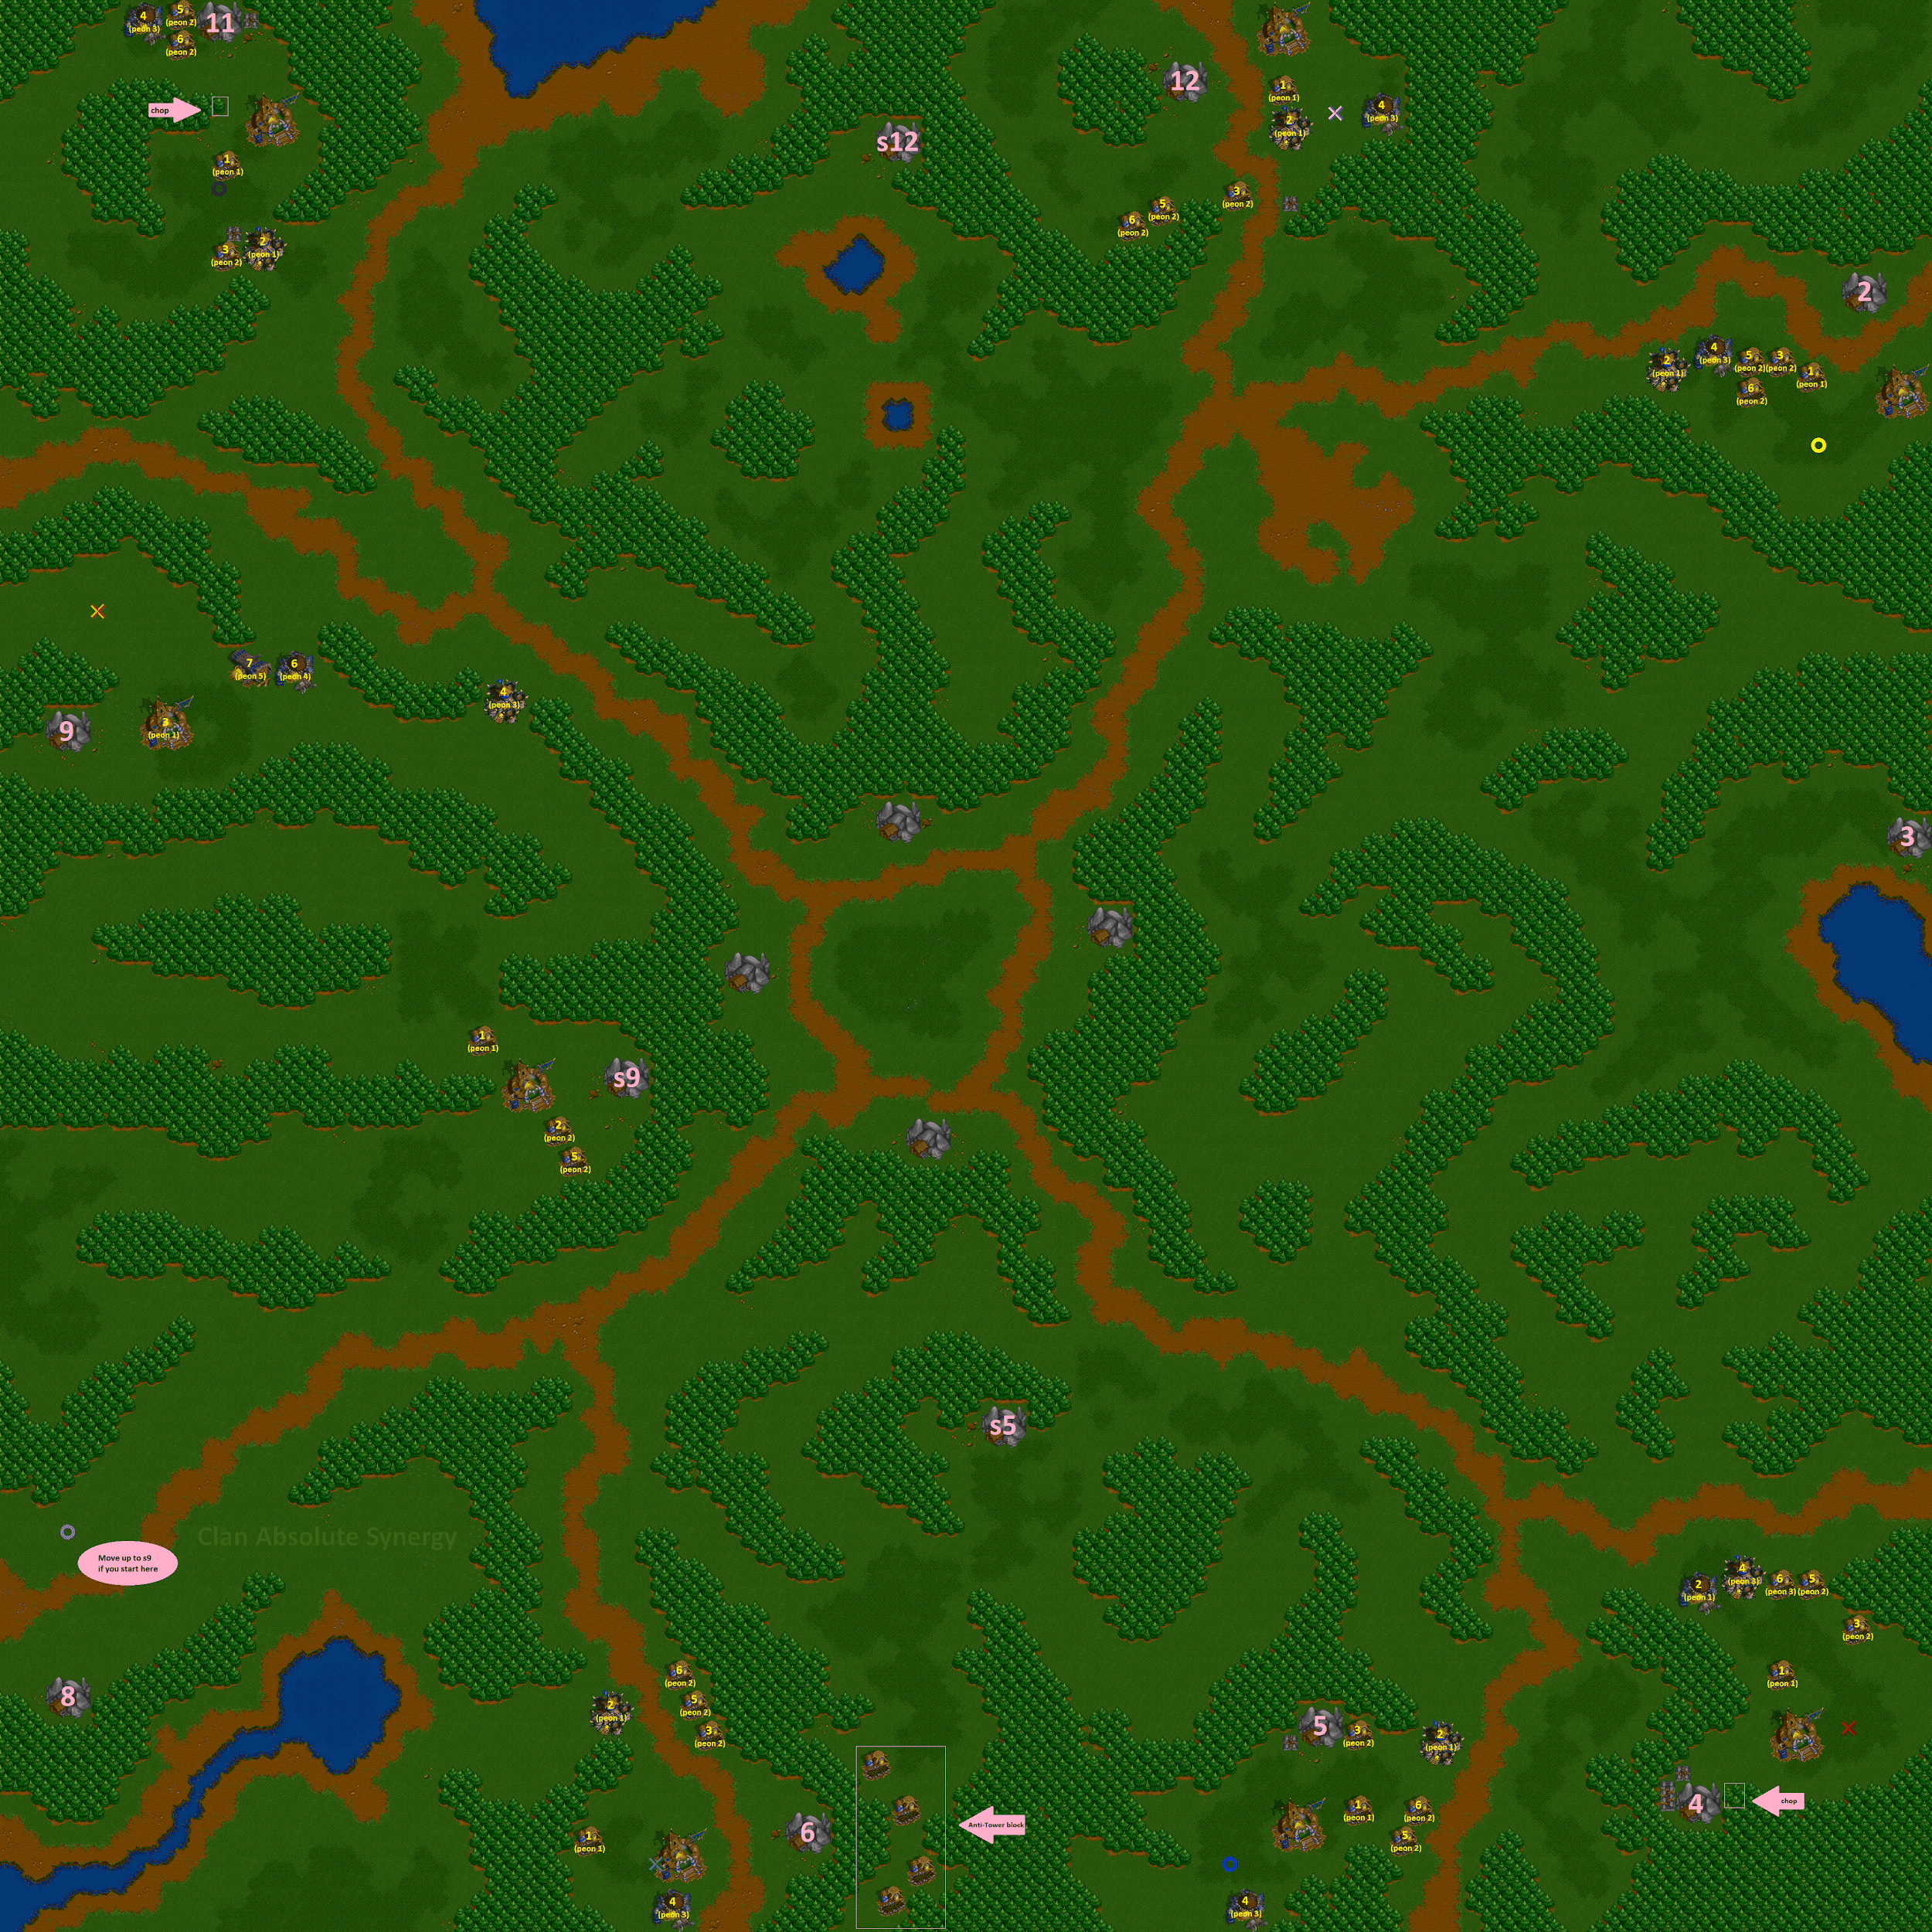

# Introduction

GoW is a very popular map and you'll need to understand **scouting**, choosing between **P1B/P1L** (peon 1 barracks, ...), **towering**, and **pocket defense** to live past two minutes.

# The first two minutes

In any map where your opponents could be right next to you you want to scout that first.

Then you scout the second nearest spot if the guy is far away then you scout in priority the spots where you think the player could try to go big (dual etc).

And if the enemy is playing greedy you try to punish him.

## 🕛 12 o'clock

## 🕑 2 o'clock

## 🕓 4 o'clock

## 🕔 5 o'clock

Your #1 priority is to know if 4 is hot (they scouted you, or you P1H,F,scout4).

4 hot: P1...L.

4 not hot: P1...B.

After barracks, G1scout-s5.

*---*

*@ 5 i'd first farm on the left of your hall and your 3x3 might want to be lower*

## 🕕 6 o'clock

Consider moving to S5 unless 5 & 4 are both hot (that will be too much pressure and you start a little behind).

-Elysian-Far-: another approach you might want to consider for 6 is going to where you have an ally. if ally is 9 go s9. if ally is 5 or 4 go s5.

if it's 4v4 then maybe stay home

if 8 is an opponent

## 🕗 8 o'clock

Nobody ever plays at 8, they always move to S9. Or if you have a death wish, go straight to center.

## 🕘 9 o'clock

## 🕚 11 o'clock

-Elysian-Far-: 11 hall placement is complicated. both the old and new (to the left one square) placements have pros to them. the old hall placement allows for a faster first 5k and may be more neighbor war-friendly.

The new hall mines out faster but requires more priming via chopping

## 🏃‍♂️ S9

-Elysian-Far-: S9 i'd only hall high like that in 1v1s. By halling [2 squares] south, you deplete the equity of a 6 opponent moving to s9. You also make it easier to deal with being raxed and get to hall faster to begin with.

# By

By fulldecent, thanks to cel, fois[a], -Elysian-Far-